# Project details.

A company that sells motorcycle parts, and they've asked with some help in analysing their sales data!

They operate three warehouses in the area, selling both retail and wholesale. They offer a variety of parts and accept credit card, cash, and bank transfer as payment methods. However, each payment type incurs a different fee.

The board of directors want to gain a better understanding of wholesale revenue by product line, and how this varies month-to-month and across warehouses. You have been tasked with calculating net revenue for each product line, grouping results by month and warehouse. The results should be filtered so that only "Wholesale" orders are included.

Personal notes :

Client requirements need net revenue for the business as different month, wholesale client type

Number of columns 4:

* **Product_line**
* **Months**
* **Warehouse**
* **Net_revenue (total * payment fee)**

They have provided you with access to their database, which contains the following table called sales:

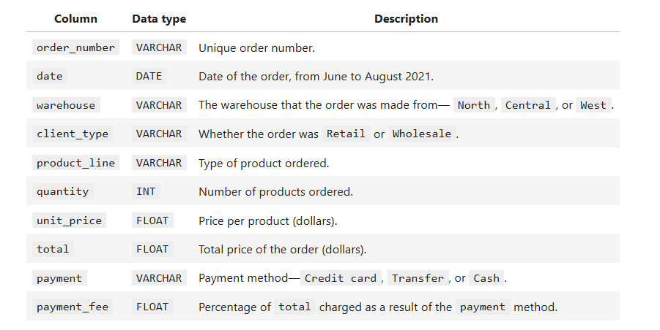

Dataset review:

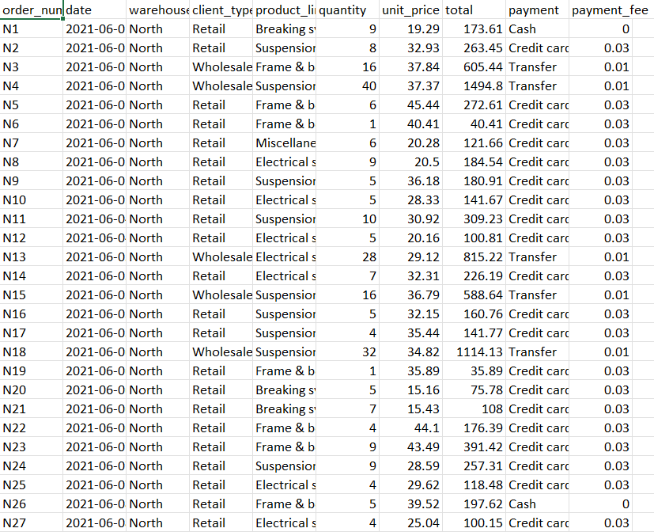

Result preview:

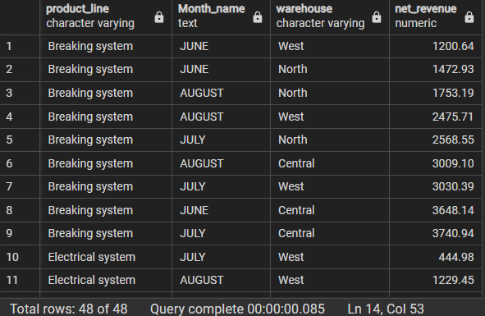

# Solution.

Create table SQL Syntax:

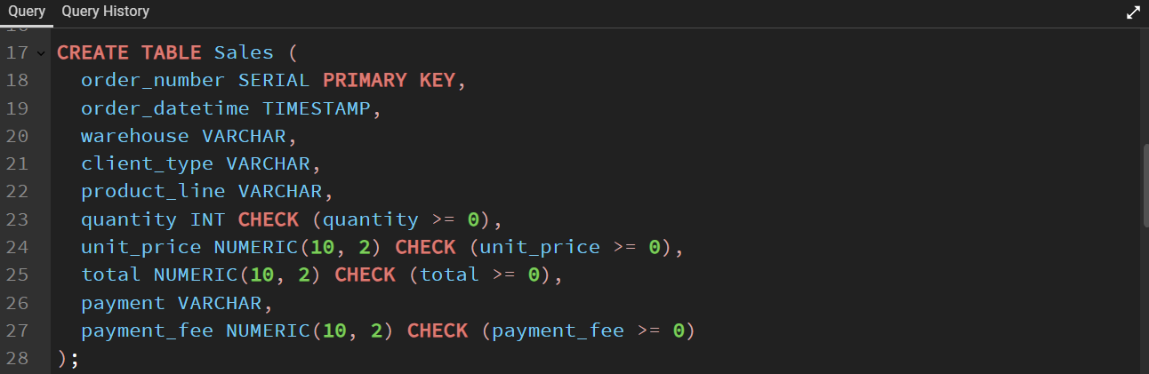

Solution as per requirement:

